GraphQL & Next.js Assessment

Section A : Concept Application
- Explain why props are the correct mechanism to pass the restaurant data into each RestaurantCard instance rather than hardcoding the values inside the component. What specific problem does props-driven design solve when the same component must render data for 50 different restaurants from an API response array?
- Props are the correct mechanism because they allow the same RestaurantCard component to receive different data for each restaurant while keeping the component reusable.
Ex :
function RestaurantCard() {
return (
<div>
<h3>Domino's</h3>
<p>Pizza</p>
<p>4.5 ⭐</p>
<p>30 mins</p>
</div>
);
}

pass the restaurant information through props:
function RestaurantCard({ name, cuisine, rating, deliveryTime }) {
return (
<div>
<h3>{name}</h3>
<p>{cuisine}</p>
<p>{rating} ⭐</p>
<p>{deliveryTime} mins</p>
</div>
);}

Then the component can be reused:
<RestaurantCard
name="Domino's"
cuisine="Pizza"
rating="4.5"
deliveryTime="30"
/>
Fetching data from API :
{restaurants.map((restaurant) => (
<RestaurantCard
key={restaurant.name}
name={restaurant.name}
cuisine={restaurant.cuisine}
rating={restaurant.rating}
deliveryTime={restaurant.deliveryTime}
/>
))}

It solves code duplication and hardcoding.
Without props, we need separate hardcoded components or values for all 50 restaurants. With props, one RestaurantCard component can display 50 different restaurants by receiving different data.

- Which two React hooks would you use to manage this behaviour, and in what order do they execute on the component's initial render? Justify why the API call must be placed inside a hook rather than directly inside the component function body
- The two React hooks I would use are useState() and useEffect().
useState() – Store the order status
It stores the current order status, such as "Preparing" or "Out for Delivery".
useEffect() – Call the API
useEffect() is used to call the backend API when the component loads and whenever a required dependency changes.
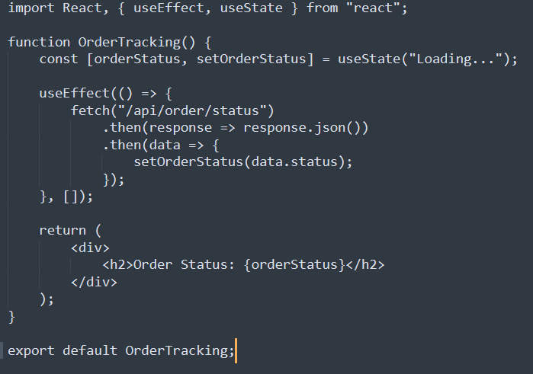
Initial render execution order
On the component's initial render:
- useState() executes first → creates the orderStatus state.
- React renders the UI with "Loading...".
- useEffect() runs after the render → calls the backend API.
- API response arrives → setOrderStatus() updates the state.
- React re-renders the component with the new status.

Flow:
useState → Render → useEffect → API call → setOrderStatus → Re-render
- How would you extract this repeated fetch logic into a custom hook to eliminate duplication? What naming convention must a custom hook follow, and what should it return so that each of the three components can consume it independently without sharing state?
- Extract the repeated fetch logic into a custom hook, useFetch(url), that returns only the data. Each component calls it with its own endpoint.
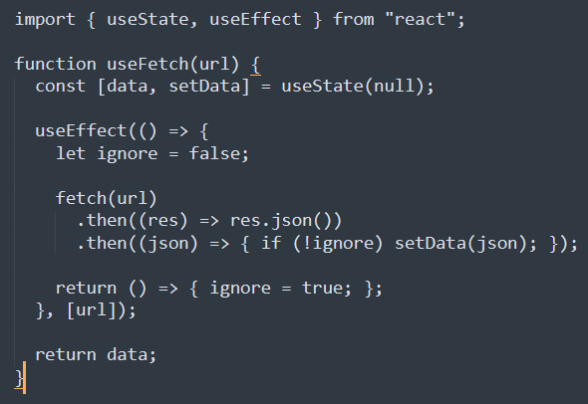
Usage :
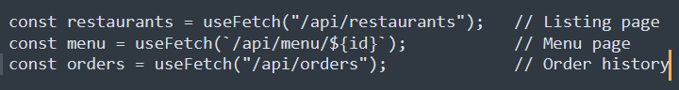
Naming convention: A custom hook's name must start with use (e.g., useFetch), so React and the linter recognize it as a hook and enforce the Rules of Hooks.
What it returns: Just the fetched data (initially null until the response arrives)
Why state is not shared: Each call to useFetch creates its own separate useState inside the calling component. The three components share the same logic but not the same data.
- Compare using React Context API versus Redux to manage this shared cart state. Under what conditions would Redux be the more suitable choice for a production-scale food delivery app, and what specific problem does Redux Thunk solve when the cart feature needs to call a server API to apply a promo code?
 | Context API | Redux
Setup | Built into React, minimal boilerplate | Needs a store, reducers, actions (Redux Toolkit reduces this)
Best for | Small to medium, low-frequency updates | Large apps with complex, frequently changing state
Re-renders | Every consumer re-renders when the context value changes | Components re-render only when their selected slice changes (useSelector)
Debugging | Limited | Redux DevTools with time-travel and action logs
Middleware | None | Supported (Thunk, Saga, logging

When Redux is more suitable (production scale):
- Many components read different parts of the cart and re-render performance matters (selectors avoid unnecessary re-renders).
- Cart logic is complex (promo codes, taxes, delivery fees, stock checks) and needs predictable, centralized reducers.
- The team is large and needs a strict, consistent state pattern.
- Debugging, action logging, and time-travel are needed to trace bugs.
- Cart must be persisted (e.g., redux-persist) or combined with other global state such as user, orders, and restaurants.
- Async workflows are heavy and need middleware.
Problem Redux Thunk solves:
Reducers must be pure and synchronous, so they cannot call an API. Redux Thunk lets an action creator return a function instead of a plain object. That function can perform async work (call the promo API) and then dispatch normal actions based on the result.
- Explain how a GraphQL API satisfies both clients from a single endpoint differently from a traditional REST API. Which GraphQL feature prevents the mobile app from receiving data it does not need, and how does this benefit network performance on a mobile connection?

- How GraphQL differs from REST
  - In REST, the server decides the shape of each response. /restaurants returns the same fixed payload to every client. To serve both clients you would either send the full profile to the mobile app (over-fetching) or build separate endpoints such as /restaurants/summary and /restaurants/admin. Getting related data (e.g., menu items) often needs extra calls (under-fetching).
  - In GraphQL, there is a single endpoint (/graphql), and the client decides the shape of the response through its query. The server exposes one schema, and each client asks only for the fields it needs.
- Feature that prevents unwanted data: Field selection in the query (client-specified queries). The server returns only the fields listed in the query, so the mobile app never receives owner details, order counts, or menu items.
- Network performance benefit on mobile:
- Smaller payloads: less data is downloaded, which saves bandwidth and mobile data.
- Faster load times: less data to transfer and parse on slow or unstable connections.
- Fewer round trips: nested data can be fetched in one request instead of several.
- Lower battery use: less network activity and less JSON parsing on the device.
- No backend changes needed: the mobile team can adjust its query without waiting for a new endpoint.
- Would you use getStaticProps or getServerSideProps to fetch the featured restaurant list, and why? Explain precisely how your choice affects Google's ability to index the page content and how it differs in the load it places on your server per visitor request.

- getStaticProps, with Incremental Static Regeneration (revalidate).
The featured list changes only once a day and is the same for every visitor, so it does not need to be fetched on every request. Next.js builds the page as HTML ahead of time and serves it from a CDN.
- Effect on Google indexing:
  - Both methods send fully rendered HTML, so Googlebot sees the restaurant names, links, and text without running JavaScript.
  - With getStaticProps, that HTML is already prebuilt and served from a CDN, so the response is very fast (low TTFB). This improves Core Web Vitals (LCP), which is a ranking factor.
  - Faster, consistent responses also let Googlebot crawl more pages within its crawl budget, and the bot never hits a slow or failing server render.
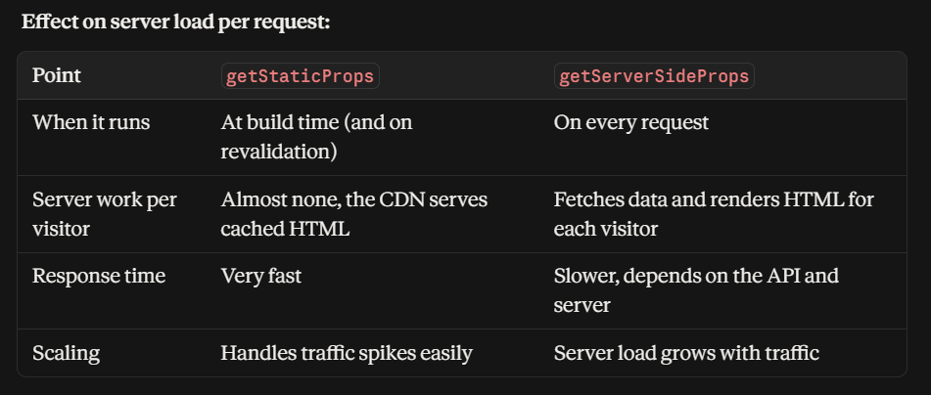
- With getStaticProps, the API is called once per revalidation period (about once a day), no matter how many visitors arrive. With getServerSideProps, 10,000 visitors mean 10,000 API calls and 10,000 server renders.

